**History and Art or Floral Design**

Ms. Crivello ~ [bcrivello@templetonusd.org](mailto:bcrivello@templetonusd.org) ~ Crivsclasses.weebly.com

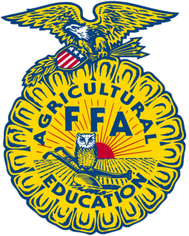

***Major Units of Instruction***

1. *Safety in Floral*
2. *History of Floral Design*
3. *Tools and Containers*
4. *Plant Anatomy*
5. *Principals of Design*
6. *Flower and Plant ID*
7. *Specialty Flowers and Events*
8. *Wedding and Holiday Flowers*
9. *Career Opportunities*

***SAE Requirements***

*Each student enrolled in an Agriculture course becomes an automatic member of the Futures Farmers of America Leadership Organization (FFA). To receive credit for the SAE portion of this class the student will need to participate in an agriculture project and commit at least 10 hr. /semester to that project. More information will be covered about this project. The FFA record book will document this project.*

***FFA Requirements***

*Each student enrolled in an Agriculture course becomes an automatic member of the Futures Farmers of America Leadership Organization (FFA). To receive credit for the FFA portion of this class the student will need to participate in three (3) FFA events at THS. One (1) of which must be an FFA Chapter Meeting.*

Class Rules and Expectations

1. Every student has the right to learn
2. The teacher has the right to teach
3. Don’t interfere with 1&2.
4. Be prepared for class
5. Don’t EVER be afraid to ask for HELP!!!!!!! NEVER EVER!
6. No FOOD no Gum
7. No Cell Phones

**Participation 25%:**

Attendance and Work Ethic during class. Includes any class notes.

**Projects/Labs 30%:**

This includes any projects done in class that require a lot of time and energy, may take time outside of class.

**Tests & Quizzes 10%:**

Checks for learning!

**Floral ID Book 5%:**

A collection of flowers and plants.

**FFA 10%:**

Attending three events during the semester, one must be a meeting.

**SAE 10%:**

Completing 10 hours of a project and completing the record book.

**Final 10%:**

The final exam at the end of the semester.

**COURSE DESCRIPTION:**  Floral Design is a UC/CSU approved Art course designed to provide students with applied study in the area of the history and art of floral design. This course focuses on the application of design principals, flower identification and plant anatomy, common floral arrangement types, containers, event planning, and career opportunities in the industry. Students will complete arrangements in this course which will be presented in a final portfolio. Participation in FFA and Supervised Agriculture Experience is required.